BQUIK OVERVIEW

In the past, rate tier values were modified on Rate Database for each individual rate code. BQUIK and BQUIKCH was created to speed up and simplify the modification process whereby updating the tiers is done by group.

 | DAILY | WEEKLY | WEEKEND | MONTHLY | MINILEASE
L | AB  AC  AM  AN  AO  AP  AQ  AR  AS  BO  BQ  BT | CM  CN  CO  CP  CQ  CR  CS  CT  CF  CG  CJ  CK | EJ  EK  EL  EM  EN  EO  FK  FL  FM  E6  E7  E8 | GA  GB  GC  GD  GE  GF  GG  GH  GI  GJ  GK  GL | FM
A | G3  G5 | DD  PC  P5  HS | 8Q  DN  H1  H2  H3 | JM  R1
B | L1  O1  MV  BP  JW  LC  G2  RF  TK  RH  S4 | DL  JX  L5  OB  76  7T  7M  LD  2U  2S  DU | EI  M6  LF  J7  X6  XR  XW  X5  XS  XT  8T
C | 5F  28  23  20  W6  B5  CH  BM  4W  84  89  8X  8Y | DM  29  24  21  W7  2T  2X  2Z  RT  RA  FC  U6  2W | 7F  8G  3A  25  22  WW  5R  L2  03  5M  PR  W1  CW

NOTE: Not all rate tiers are used (this depends on location; different areas have different needs). The maximum # of rate codes allowed in each Rate Category is 12. The rate must be loaded on Rate Database in order for it to appear on BQUIK. To add more Rate code in BQUIK requires a project.
USER’S GUIDE TO USING BQUIK AND BQUIKCH

To display a BQUIK screen:
- Type: /FOR BQUIK

To display daily, weekly, monthly or mini-lease rates for a specific station or trigger:
- ACTION: DIS
- DATE: (DDMMMYY), e.g. 15JAN08 or leave DATE black to display current time period.
- RATE CAT: Type L, A, B, or C in (this letter does not indicate rate category; it is how the rate codes are grouped).
- RATE TYPE: D (daily), W (weekly), K (weekend), M (monthly), L (mini-lease).
- STATION: Type the desired station number in, e.g. 00585 or all locations within the trigger, e.g. 00585, 03413 (up to 12 locations). Be careful of the location for the 12th station.
- MCC: Enter X to display Cool Cars.
- Press ENTER twice or F7 for an instant display. There are two screens for each display. The first holds the rate codes and prices for car groups X-G. The second holds the rate codes and prices for all “special equipment” car groups (V, W, etc.)

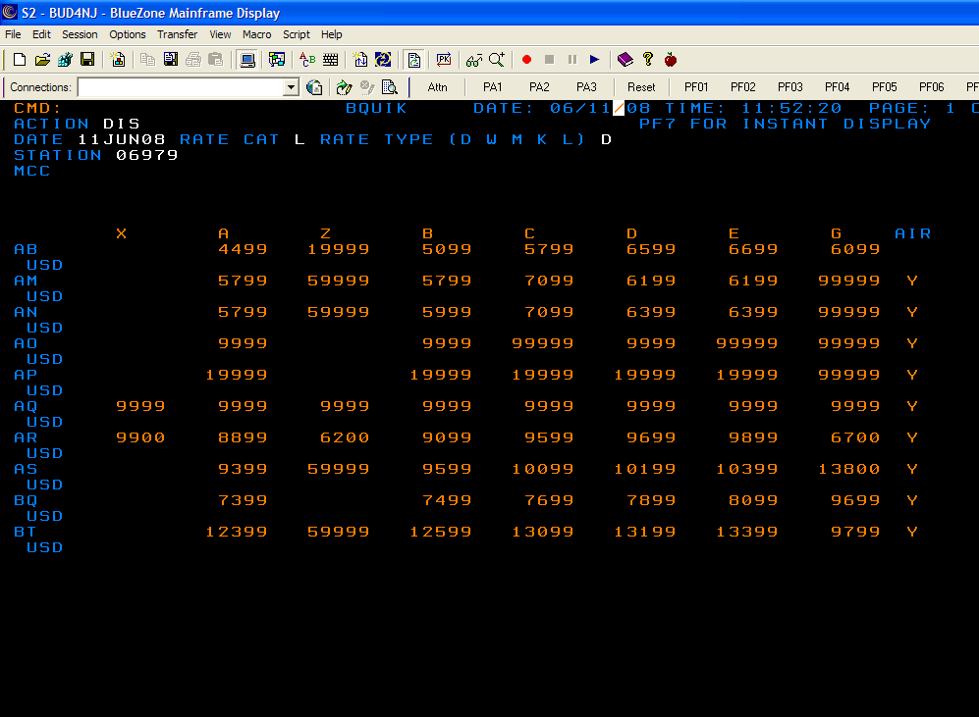

NOTE: If more than one time period exists in Rate Database for a rate or rates an “*” will appear to the left of these rates on BQUIK.

Also, if the rate indicators on Rate Database are “Y” thus sending a rate to the airline systems, a “Y” also appears to the right of the tier on BQUIK. If there is an “N” on BQUIK the rate does not go to the airline systems.

To make modifications to tiers:
- ACTION: MOD
- Type the desired values beneath the existing values. Type the values in the same format as it appears (no decimal points). You must tab from field to field
- Press ENTER one for “special equipment” rate change screen, make any changes, and ENTER again (DATA ACCEPTED AND SENT FOR APPROVAL) will appear at the bottom of the screen.

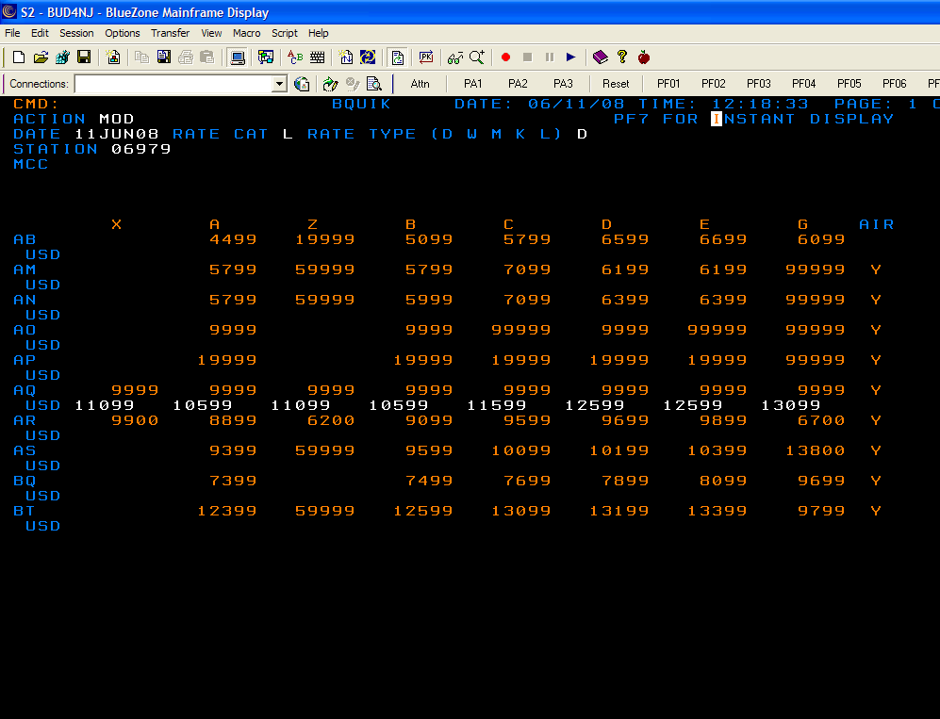

NOTE: Please remember that if an “*” appears a time period or multiple time periods exist. Your rate changes will only effect the time period within the date displayed.
Completing a MOD transaction on BQUIK does not immediately send the updates rates across to Rate Database. Your MOD transactions sent the new values to BQUIKCH where they are first reviewed and/or proofread before being accepted.

To display BQUIKCH:
- Clear the screen after BQUIK modifications have been completed.
- Type: /FOR BQUIKCH

There are 2 methods to display a transaction already done on BQUK:
1) Type LST in Action and press ENTER twice or F7 to list all transactions waiting to be accepted on the BQUIK queue. A list of records will appear on the screen by product and by station (an “*” next to the station means the transaction was done for multiple stations) place an X in front of the desired record and press ENTER or F7. If it was a modification for Cool Cars, then you will need to input “X” next to MCC.

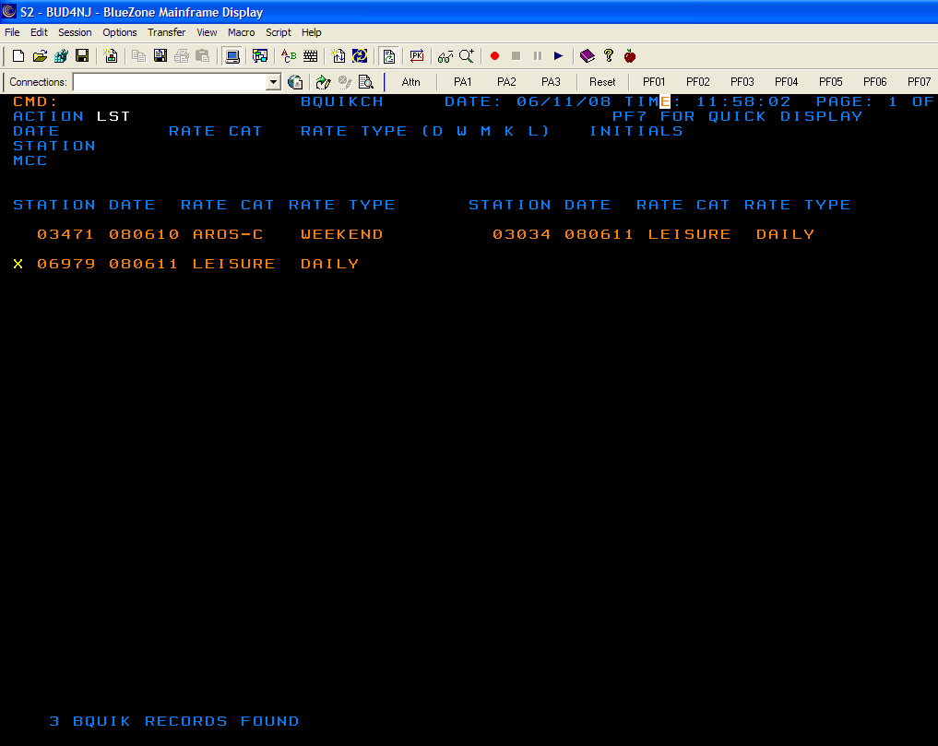

OR

  - Type DIS in ACTION, type the station number in STATION, and leave all other fields blank. Press ENTER twice or F7, and this will automatically display any transactions waiting in the queue

NOTE: this will access each transaction for the location entered in the same order that they were done, e.g. if daily changes were entered first and weekly changes entered second on BQUIK, this transaction will not let you display the weekly changes before the daily. If you are not ready to accept the daily, but want to accept the weekly, the weekly can only be accessed by using the LST transaction and choosing the weekly changes by placing an “X” in front of it as stated in the first bullet. The same scenario exists with different time periods. They must be accepted in the order they were done

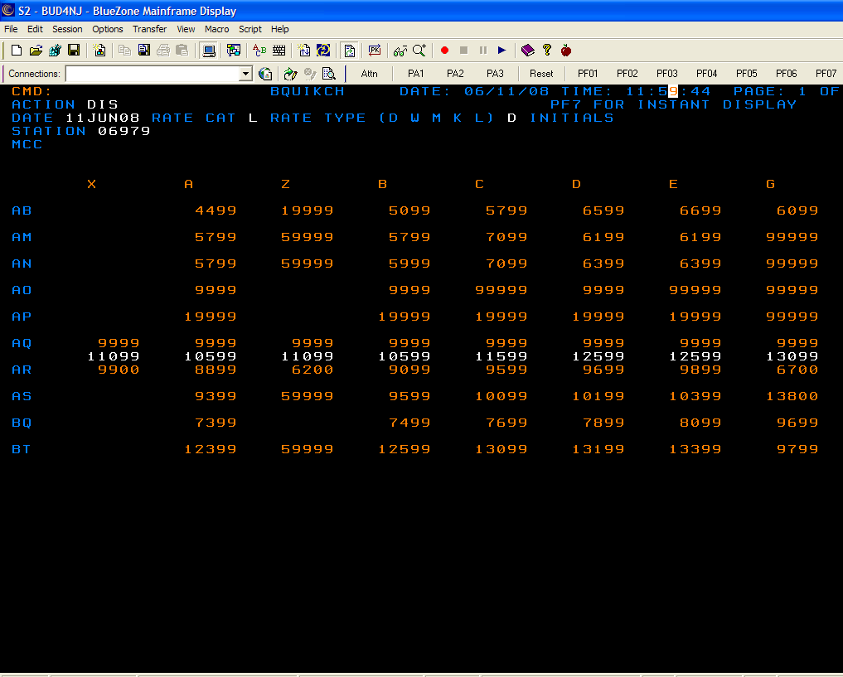

Accepting rate changes:
- After displaying the transaction, the values should be looked over for accuracy. The user can then perform any of the following desired actions:
  - To accept the changes done in BQUIK:
    - Type ACC in ACTION, and type your initials where indicated. Press ENTER, look over “special equipment” screen for accuracy, and press ENTER again. “RATES ACCEPTED” will appear when the transaction has been completed.
You can correct any mistakes while using the ACC action by overwriting the errors.
  - To decline the changes done in BQUIK:
    - Type DEC in ACTION and type your initials where indicated. Press ENTER twice or use F7. “TRANSACTION DECLINED” will appear when the transaction has been completed.
  - To modify the changes done in BQUIK:
    - Type UPD in ACTION and type your initials where indicated. Update any of the prices that need to be changed. Press ENTER. “RATES UPDATED” will appear when the transaction has been completed.

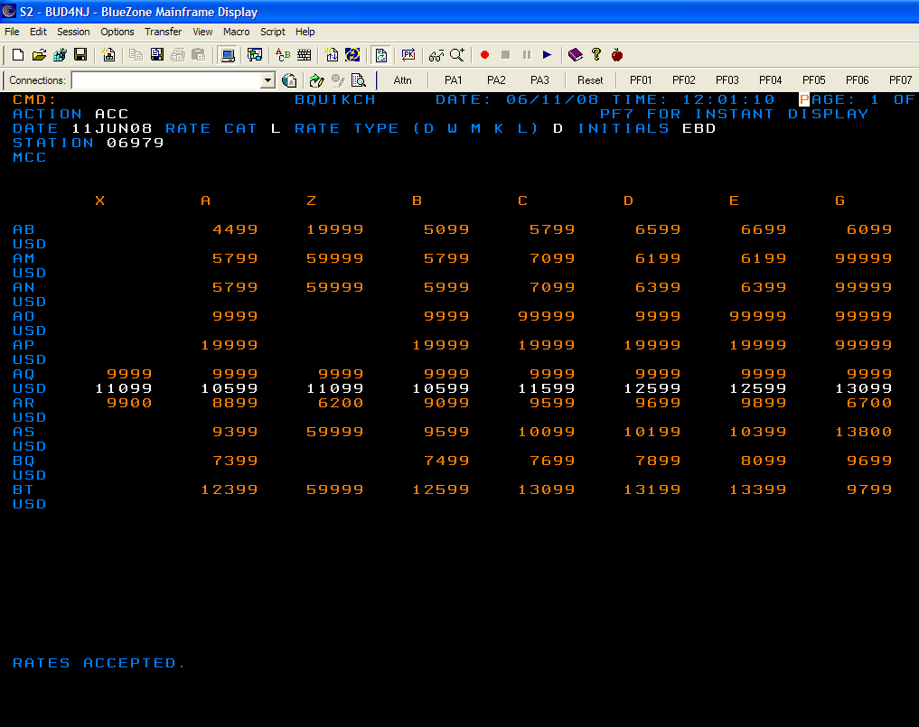

Screens for BQUIK and BQUIKCH may be printed at any time by typing PRT in ACTION.

AFTER ACCEPTING CHANGES IN BQUIKCH, YOU SHOULD CHECK YOUR WORK IN THE BQUIK SCREEN.

